HALLOWEEN CAMP
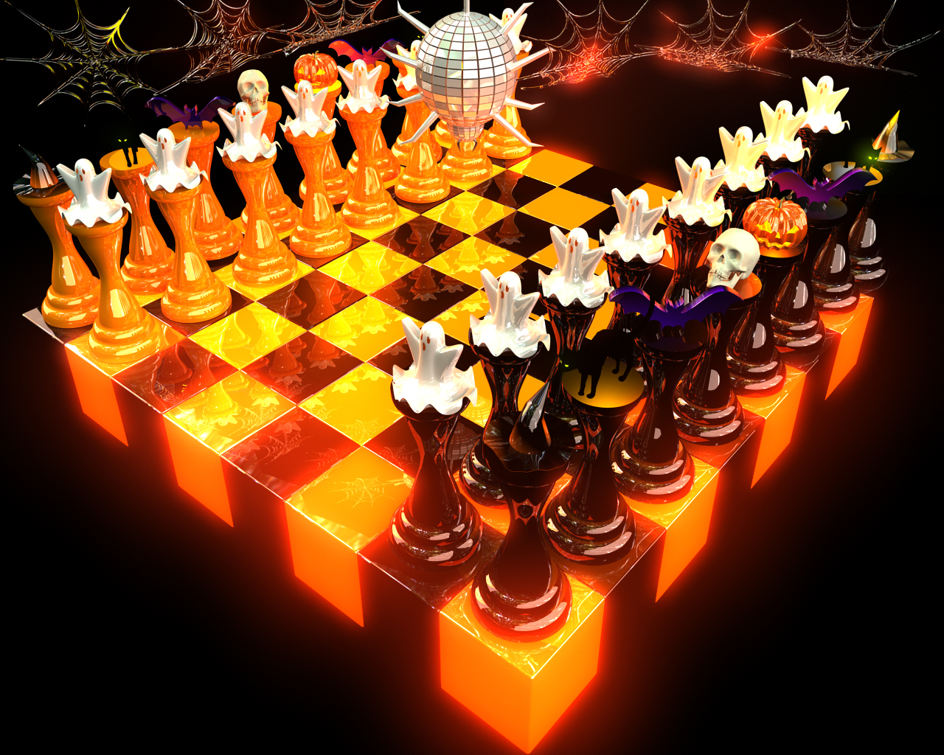

nQ NOVEMBER 2 Qn

MIDDLEGAME STRATEGY
PRINCIPLES / ATTACKS / STRATEGIES

IM LEVON ALTOUNIAN
2008-CURRENT ARIZONA STATE CHAMPION

Wild Cats (100-400) 9:30 - 11:30 a.m $35
Coyotes (500-800) 11:45 - 1:45 p.m $35
Hawks (900-1250) 2:00 - 4:00 p.m $35

BEST COSTUME PRIZE FOR EACH GROUP!
SIGN UP EARLY / 5-15 PER GROUP

Family discounts available.
To Register: Contact Levon Altounian at (520) 891-3632, or e-mail laltounian@msn.com
Site: 2772 N. Neruda Ln. (Craycroft and Glenn, heading East on Glenn)

