BIO5 CHESS CLUB

Blitz Chess Tournament + Special Lecture
Friday, May 3rd, 2013
Sponsored by Rod Wing, Held at UA’s BIO5 Institute

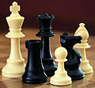

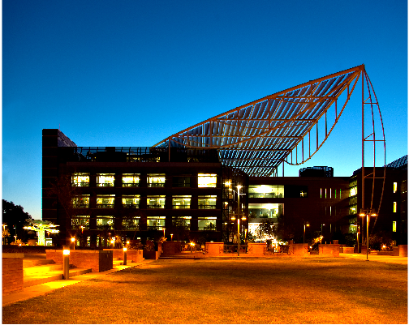

LOCATION: Keating Bio Research Building, University of Arizona, 1757 East Helen Street, Tucson, AZ.
SPECIAL LECTURE: 6:00-6:45 PM – IM Levon Altounian (AZ State Champion) will give a free chess lesson aimed at USCF 1400 rated chess players and higher, and adults.

Chess Lesson for players below 1400: 6:00-6:45 – by an advanced BIO5 Chess Club player (TBD)

BLITZ TOURNAMENT DESCRIPTION: 4 rounds, double Swiss –open to all, USCF rating will be used for pairing and prize determination only.

BLITZ REGISTRATION: 5:45-7:00 PM Registration; 7:15 PM Round One starts.
PRIZES: 1ST PLACE: $40 / 2ND PLACE: $25 / 3D place: $15 Open section.
$15 for best performance U1800, U1500, U1000 and U700 categories.
IM Levon Altounian’s participation is possible. He is not eligible for prize money.
Cash prize fund is based on 30 entries. 50% Guaranteed.
INFORMATION: Lena Sheveleva (520) 609-8325 or lena.shevelev@gmail.com
REGISTRATION: On Site only; Entry Fee: $5 INFORMATION: Lena Sheveleva (520) 609-8325 or lena.shevelev@gmail.com
Visit http://www.arizonachessforschools.com/ to download the flyer or for more information.

